EX No:1b | EDA DATA CLEANING

AIM

To perform exploratory data analysis on the Fashion Products Dataset by examining the dataset structure, dimensions, data types, statistical characteristics, missing values, brand-wise and category-wise product distributions, product-wise sales and pricing patterns, customer ratings and review trends, price and discount analysis, interactive filters, parameter-based analysis, and creating an interactive dashboard for effective fashion product analysis and data-driven decision-making.

ALGORITHM
- Import the required libraries such as Pandas, NumPy, Matplotlib, and Seaborn.
- Load the Fashion Products Dataset into a Pandas DataFrame.
- Display the first five and last five records of the dataset.
- Display the dataset information, shape, column names, and data types.
- Generate descriptive statistical information for the numerical attributes.
- Identify the number of missing values in each column.
- Remove blank rows and duplicate records from the dataset.
- Perform data cleaning and standardization on the required categorical and numerical attributes.
- Analyze the distribution of fashion products across different brands and product categories.
- Analyze the price and discount distribution of fashion products.
- Analyze product-wise and category-wise pricing and rating patterns.
- Analyze the customer rating and review patterns across different fashion products and categories.
- Analyze the relationship between product price, discount, ratings, and reviews.
- Create interactive visualizations including bar charts, pie charts, line charts, Brand Filter, Category Filter, Minimum Price/Rating Parameter, and an interactive Fashion Products Analytics Dashboard.
- Export the cleaned Fashion Products Dataset into CSV format and display a confirmation message after successful file creation.

CODE
import os
import pandas as pd
import numpy as np
path = "/content/Food_Waste_Prediction_Dataset.csv"
print("Dataset path:", path)
df = pd.read_csv(path)

print("\nFirst 5 rows:")
display(df.head())
print("\nLast 5 rows:")
display(df.tail())
print("\nDataset information:")
df.info()
print("\nShape:")
print(df.shape)
print("\nColumns:")
print(df.columns.tolist())
print("\nData types:")
print(df.dtypes)
print("\nStatistical description:")
display(df.describe())
print("\nMissing values:")
display(df.isnull().sum())
df = df.dropna(how="all")
df = df.drop_duplicates()
print("\nDataset after removing blank rows and duplicates:")
print(df.shape)
df["Remaining_Quantity"] = (
df["Prepared_Quantity"] - df["Sold_Quantity"]
)
print("\nRemaining Quantity:")
display(
df[
[
"Prepared_Quantity",
"Sold_Quantity",
"Remaining_Quantity"
]
].head()
)
df["Waste_Percentage"] = (
df["Waste_Amount_kg"] /
df["Prepared_Quantity"]
) * 100
print("\nWaste Percentage:")
display(
df[
[
"Restaurant_Name",
"Prepared_Quantity",
"Waste_Amount_kg",
"Waste_Percentage"
]
].head()
)
print("\nRestaurant-wise Food Waste:")
display(
df.groupby("Restaurant_Name")["Waste_Amount_kg"]
.sum()
.sort_values(ascending=False)
)
print("\nCity-wise Food Waste:")
display(
df.groupby("City")["Waste_Amount_kg"]
.sum()
.sort_values(ascending=False)
)
print("\nFood-item-wise Food Waste:")
display(
df.groupby("Food_Item")["Waste_Amount_kg"]
.sum()
.sort_values(ascending=False)
)
df["Date"] = pd.to_datetime(df["Date"])
print("\nFood Waste Trend:")
display(
df.groupby("Date")["Waste_Amount_kg"]
.sum()
)
print("\nCorrelation:")
display(
df.corr(numeric_only=True)
)
df.to_csv(
"Food_Waste_Cleaned.csv",
index=False
)
df.to_excel(
"Food_Waste_Cleaned.xlsx",
index=False
)
df.to_json(
"Food_Waste_Cleaned.json",
orient="records",
indent=4
)
print("\nCSV, Excel and JSON files created successfully.")

OUTPUT

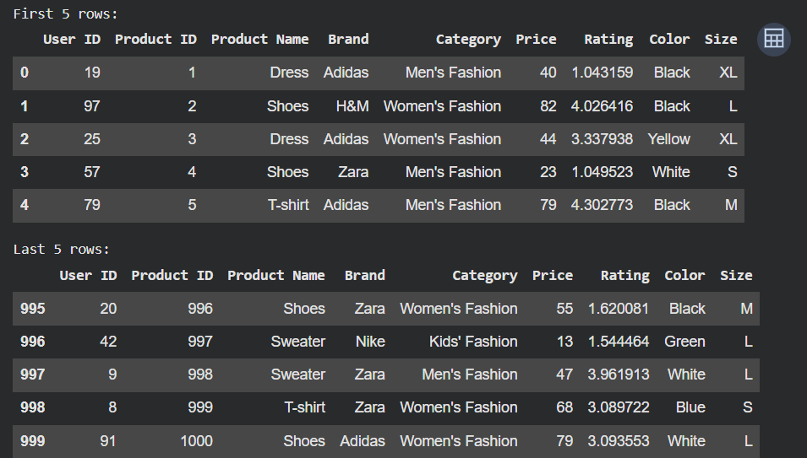

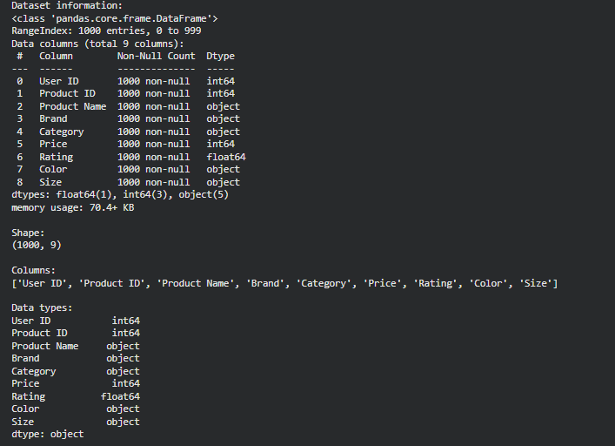

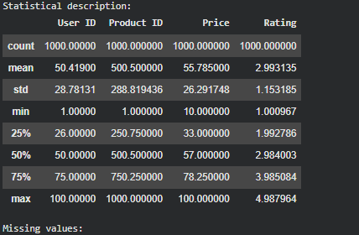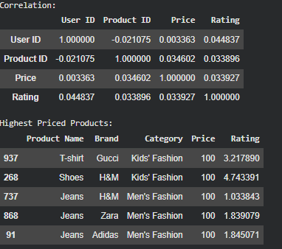

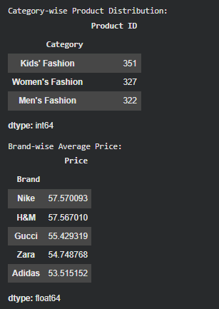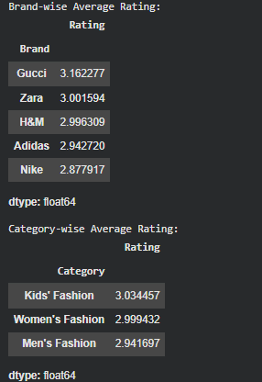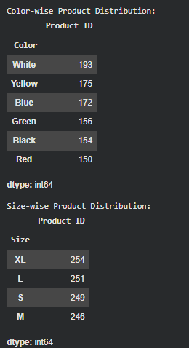

RESULT

